OS LAB 09

TASK1:
when semaphore = 1;
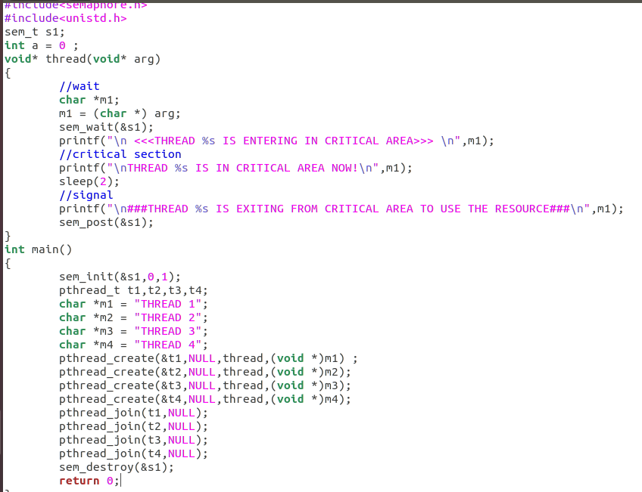

Result:
when semaphore = 1;

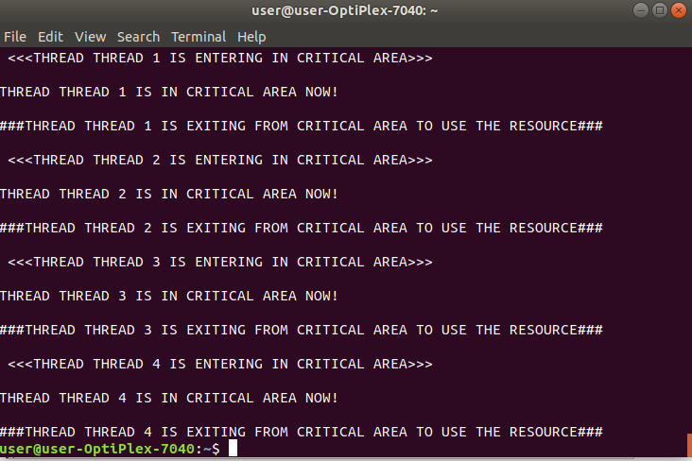

when semaphore = 5;
